

Undergraduate Internship Report
Program: Bachelor of Engineering
Department: Computer Science and Engineering
Academic Year: 2022 – 2026

Internship Duration: SEPTEMBER 2025 – NOVEMBER 2025
Name of Student: Dasara Sai Ram
Register Number: 192210258
Batch: 2022 – 2026
Internship Organization: JBK IT Technologies, Dilshuknagar, Hyderabad, India
Supervisor in Company: M. Mary Sindhu

1. Internship Completion Certificate
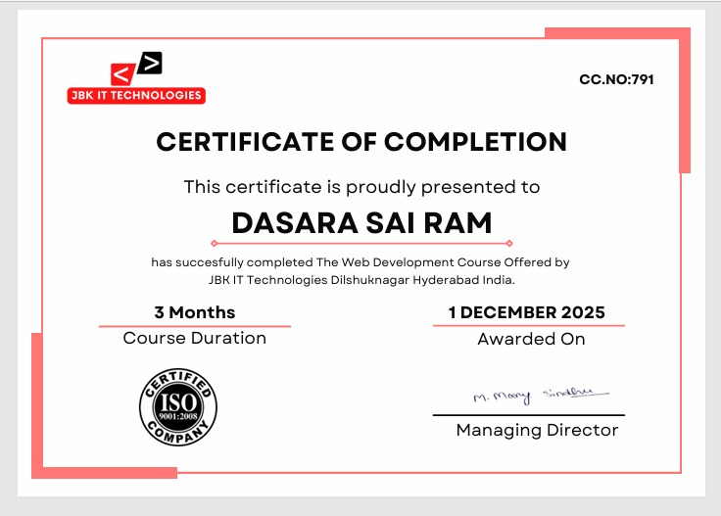

2. Student Declaration

I Dasara Sai Ram, a student of Bachelor of Engineering in the Department of Computer Science and Engineering, solemnly affirm that the internship experience documented in this report reflects my direct involvement in a formal organizational setting, actively engaged in industry-relevant operations.

During the internship period from 01/09/2025 to 30/11/2025, I was entrusted with tasks and responsibilities that were integral to the company’s ongoing functions. The insights and observations included herein are a true representation of the work culture, technical exposure, and professional interactions I encountered.

This report has been prepared based on actual experiences and contributions during my time with the organization. I have abided by the professional conduct expected of an intern and ensured that the contents of this document are factual, original, and aligned with the intended academic and industrial learning objectives.

Signature of the Student
Date: __________

3. Company Overview
Name of the Company:
JBK IT Technologies
Nature of Business / Industry Sector: Professional Training and Coaching
Brief History & Overview:
JBK IT Technologies is an ISO 9001:2008 certified professional training and coaching institute based in Dilshuknagar, Hyderabad, India, established with the vision of bridging the gap between academic learning and industry requirements. The organization specializes in delivering job-oriented courses in Web Development, Java Full Stack, Python Full Stack, SAP FICO/MM, Power BI, Advanced Excel, Tally with GST, and Digital Marketing, combining theoretical knowledge with practical exposure. Through structured training programs, hands-on projects, and mentorship, JBK IT Technologies equips students and professionals with industry-relevant skills, ensuring they are well-prepared for real-world challenges in IT and finance domains.
Key areas of Work
- Web Application Development– Developing web pages and basic web applications using HTML, CSS, and JavaScript while understanding the structure and behaviour of modern websites.
- User Interface Design– Creating responsive and user-friendly webpage layouts using styling techniques and responsive design principles.
- Frontend Development Practice– Working on frontend development tasks such as page layout creation, styling components, and improving visual presentation of web pages.
- Project Documentation and Learning– Documenting learning progress, understanding development workflows, and maintaining proper project structure during development.
4. Internship Role and Objectives
Internship Title/Designation:
Web Developer Intern
Objectives:
The primary objective of this study was to build a strong foundation in the fundamentals of web development. This included understanding how websites function, how data flows between clients and servers, and how browsers interpret and render content. Alongside these concepts, I also gained familiarity with essential elements such as domain names, hosting, and web protocols, which are critical for managing and deploying websites effectively.
A major goal was to gain practical experience in HTML, CSS, and JavaScript, the core technologies of frontend development. HTML provided the structure of web pages, CSS handled styling and layout, and JavaScript added interactivity and dynamic behavior. Through hands-on practice, I was able to move beyond theory and develop functional, responsive web pages that demonstrated real-world usability.

Another important objective was to understand the web development lifecycle—from planning and wireframing to coding and deployment. This involved learning how to organize content effectively, design intuitive navigation, and apply UX/UI principles to create websites that are both visually appealing and user-friendly.

Developing responsive and accessible interfaces was emphasized throughout the course. With the growing use of mobile devices, I learned techniques such as flexible layouts, media queries, and fluid images to ensure websites adapt seamlessly to different screen sizes. Accessibility and readability were also considered to make websites usable for a diverse range of users.

The course also focused on improving debugging and problem-solving skills, teaching me how to identify, analyze, and fix errors using browser developer tools and logical approaches. This strengthened my confidence in handling unexpected challenges during development.

Finally, the study highlighted the importance of real-world workflows and continuous learning. I gained exposure to version control systems and collaborative practices, which bridged the gap between academic learning and industry standards. At the same time, I was encouraged to experiment creatively with layouts and interactive elements, fostering innovation in design. The course instilled a mindset of lifelong learning, reminding me that web technologies evolve rapidly and developers must stay adaptable to succeed in the digital landscape.

5. Technologies & Tools

During my Web Development training at JBK IT Technologies, I gained practical exposure to the essential tools and technologies that form the backbone of modern frontend development. This experience not only strengthened my technical foundation but also helped me understand how professional workflows are structured in real-world environments.

- HTML5 – Used to design well-structured and semantic web pages. I learned how to organize content using headers, sections, forms, and multimedia elements. Semantic tags improved accessibility and search engine optimization, while proper structuring ensured clarity and usability.

- CSS3 – Applied styling techniques such as colors, fonts, spacing, and layouts. I practiced responsive design using Flexbox, Grid, and media queries, making websites adaptable across desktops, tablets, and mobile devices. I also experimented with animations and transitions to enhance user engagement.

- JavaScript (ES6) – Implemented interactivity through form validation, event handling, and DOM manipulation. I explored ES6 features such as arrow functions, template literals, and modules, which improved code readability and efficiency. This helped me build dynamic and interactive web pages that responded to user actions.

- Bootstrap – Leveraged pre-built components like navigation bars, buttons, modals, and responsive grids to accelerate development. Bootstrap’s grid system allowed me to design layouts that automatically adjusted to different screen sizes, ensuring consistency and efficiency.

- Tailwind CSS – Practiced utility-first styling to create customized layouts and design systems. Tailwind’s utility classes gave me greater flexibility in spacing, typography, and colors, enabling me to build highly customized and modern user interfaces.

- Responsive Design Principles – Focused on mobile-first design, ensuring websites adapt seamlessly to different devices. I tested layouts across multiple screen sizes and emphasized accessibility, readability, and ease of navigation for diverse users.

- UX/UI Concepts – Learned the importance of intuitive navigation, color schemes, typography, and layout structures. I ensured that interactive elements such as buttons and forms were user-friendly and accessible, enhancing overall user satisfaction.

- Debugging & Testing Tools – Used Chrome Developer Tools to inspect elements, analyze styles, and debug JavaScript errors. This improved my problem-solving skills and helped me deliver functional, error-free applications.

- Project Documentation & Workflow Discipline -Maintained clean code practices with proper indentation, meaningful variable names, and modular structures. I documented my learning progress and followed structured workflows, preparing me for industry-standard practices.

6. Learning Outcomes

The Web Development training at JBK IT Technologies was a transformative experience, providing me with a strong foundation in the fundamentals of frontend development. One of the most significant outcomes was gaining clarity on how websites function, how data flows between clients and servers, and how browsers interpret and render content. This helped me bridge the gap between academic theory and practical application.

From a technical perspective, I developed proficiency in HTML5, CSS3, and JavaScript, which allowed me to build structured, styled, and interactive web pages. I learned how to use Bootstrap and Tailwind CSS to accelerate development and maintain design consistency, while also practicing responsive design techniques to ensure websites adapt seamlessly across desktops, tablets, and mobile devices.

Another important outcome was understanding the web development lifecycle—planning, designing, coding, testing, and deployment. I gained practical exposure to organizing content effectively, creating intuitive navigation, and applying UX/UI principles to design user-friendly interfaces. This experience emphasized the importance of accessibility, readability, and smooth navigation in modern websites.

Debugging and problem-solving were integral parts of the training. Using browser developer tools, I learned to identify and fix errors quickly, which improved my confidence in handling unexpected challenges. Clean coding practices, proper documentation, and maintaining project structure were also emphasized, preparing me for industry-standard workflows.

Finally, the training instilled the importance of continuous learning and adaptability. Web technologies evolve rapidly, and I learned that staying updated with new tools, frameworks, and best practices is essential for long-term success. This mindset of lifelong learning motivates me to expand into advanced frameworks and strengthen my career as a web developer.

Feedback from Supervisor:

The feedback from my supervisor reflected the progress I made throughout the internship. I was appreciated for proactively resolving technical issues, demonstrating a willingness to explore solutions independently, and maintaining a positive attitude even in complex situations. My supervisor also commended my growth in collaboration and communication, especially my ability to work effectively in a team setting using GitHub. I received encouraging feedback on the quality, consistency, and structure of my code, which had improved significantly by the end of the internship.

Overall, the challenges I encountered during the internship helped shape me into a more confident and competent developer. They taught me how to approach problems methodically, seek help when necessary, and apply theoretical knowledge to practical contexts. These experiences have prepared me to tackle future industry challenges with a strong problem-solving mindset and professional resilience.

7. Software Development Life Cycle (SDLC) Followed During Internship

During my internship, I understood the basic phases of the Software Development Life Cycle (SDLC) used in web development projects.
- Requirement Analysis – In this phase, the requirements of the web application were clearly identified. I understood the purpose of the project, identified the target users, and analysed the necessary features such as interactive user interfaces, dynamic components, form handling, and API integration. Both functional and non-functional requirements were considered to ensure clarity before starting development.
- System Design – After analysing the requirements, the system design phase was carried out. In this stage, the overall structure of the web application and the layout of the user interface were planned. Different sections of the application such as navigation menus, content areas, and interactive UI elements were designed. The focus was on creating a clean, responsive, and user-friendly interface to improve the overall user experience.
- Implementation (Coding Phase) – This phase involved the actual development of the application. During this stage, I worked on developing different components of the web application. The user interface was created using HTML, CSS, and JavaScript, and dynamic behaviour was implemented where required. I also practiced writing structured code, organizing project files properly, and ensuring that the application functions correctly according to the requirements.
- Testing Phase – In the testing phase, the application was evaluated to ensure that it worked correctly without errors. Functional testing was performed to verify that all elements such as buttons, forms, and navigation components worked as expected. Browser developer tools were used to identify and debug errors. The application was also tested for responsiveness to ensure it worked properly on different screen sizes.
- Deployment and Maintenance – Although the internship mainly focused on development activities, I gained basic knowledge about deployment practices and version control systems. I learned how developers manage code using Git and GitHub, track changes, and maintain project versions. This helped me understand how applications are updated and maintained in real-world software development environments, as well as the importance of proper documentation and collaboration
within a development team.

8. Implementation Results
Developed a Car Rental Website.

Code Implementation:
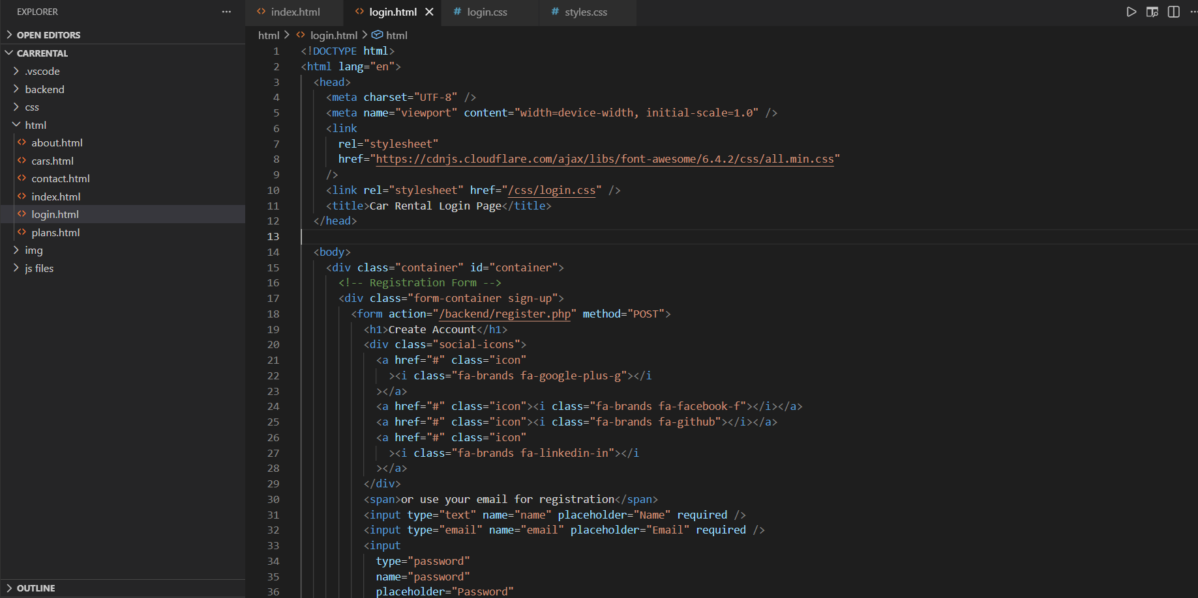
Login Page:

Secure login form with username and password fields, ensuring authenticated access.

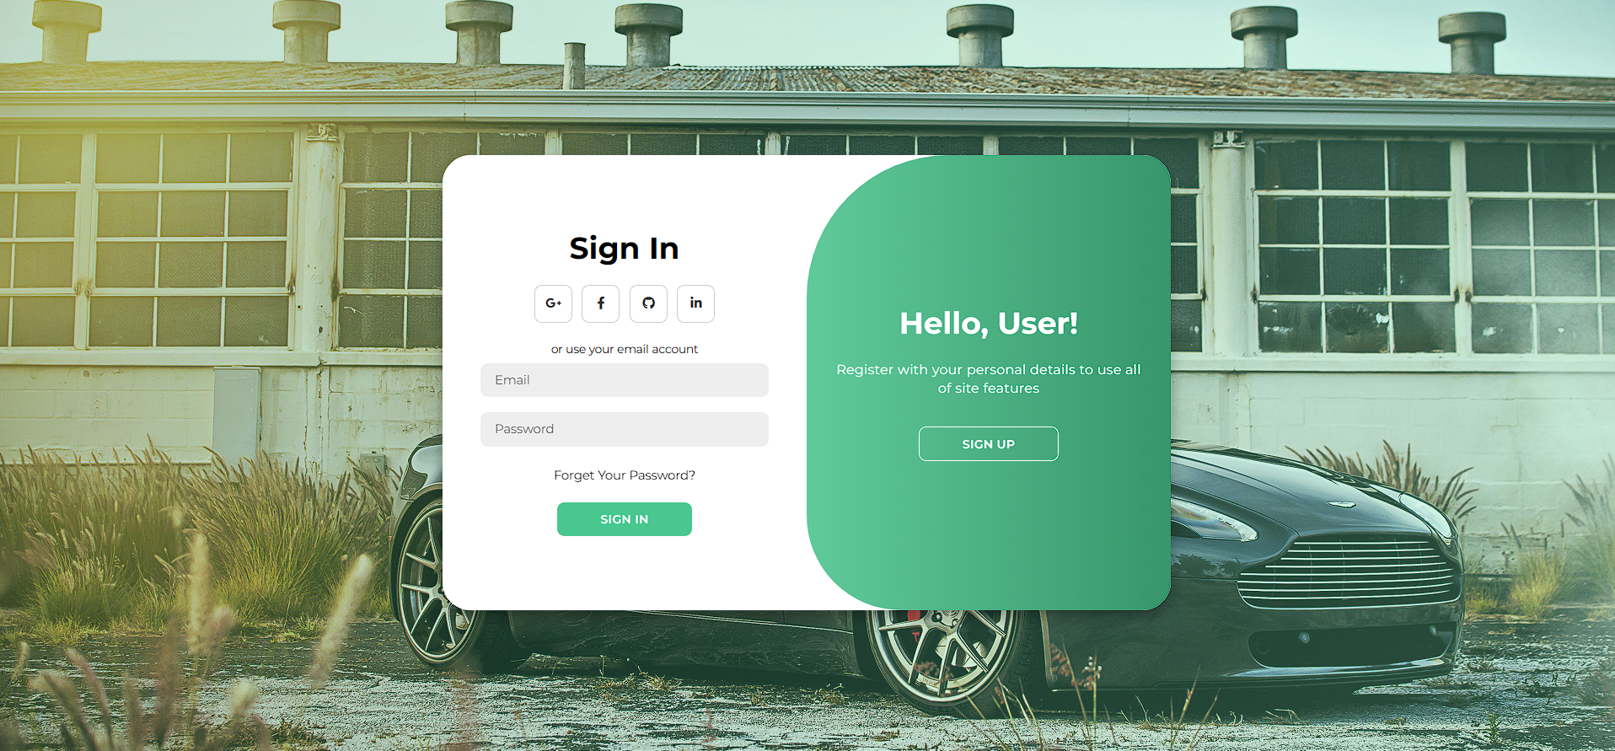

Home Page:

Displays available cars, rental options, and navigation to other modules.



Contact us:

Provides a form for customer queries and company contact details.



Pick Your Wheels:

Car selection module showing available vehicles with details and booking options

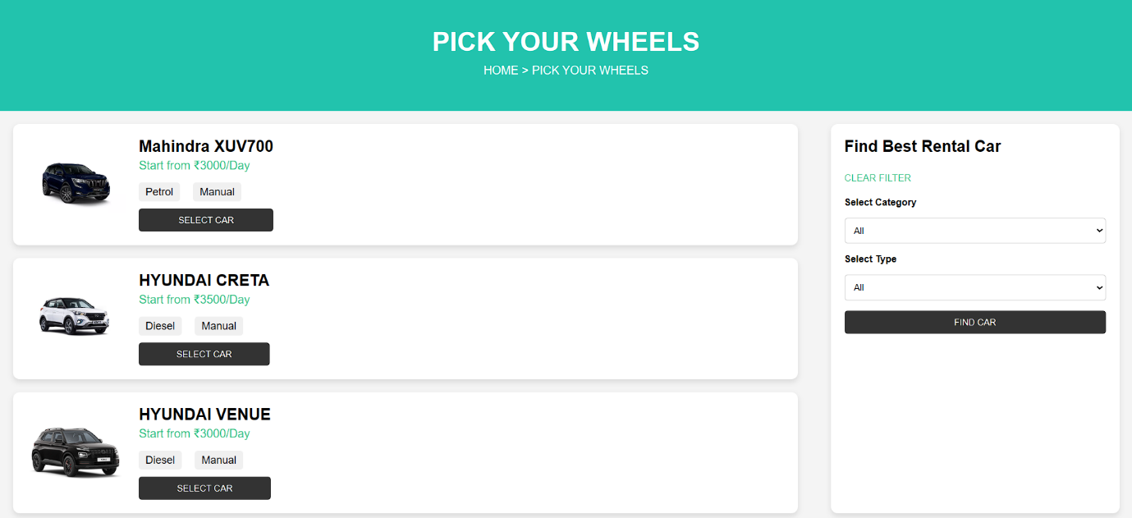

Our Plans:

Rental packages (daily, weekly, monthly) with pricing and features.
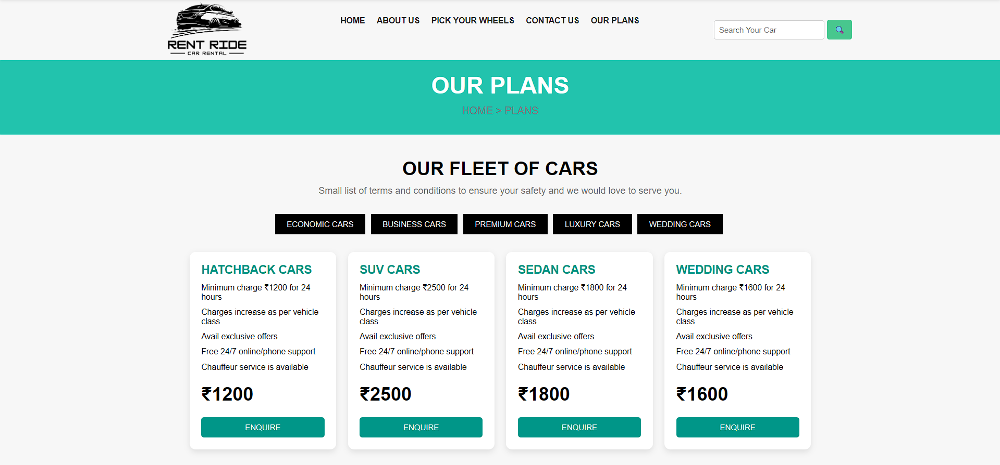

9. Overall Experience
The Web Development training at JBK IT Technologies was a valuable and enriching experience that provided me with practical knowledge in frontend web development. Through this program, I learned how to build structured web pages using HTML, design responsive layouts with CSS, and add interactivity with JavaScript. I also gained exposure to frameworks such as Bootstrap and Tailwind CSS, which helped me accelerate development and maintain design consistency.
This training strengthened my technical knowledge, coding discipline, and understanding of real-world web development workflows. It improved my ability to debug issues, document projects, and follow structured development practices. Most importantly, it boosted my confidence in applying theoretical concepts to practical projects, preparing me for future challenges in the software industry.

10.Faculty Mentor’s Remarks

This is to certify that the internship report submitted by Dasara Sai Ram has been reviewed, and it is evident that the internship was undertaken at a bonafide organization. The work documented is satisfactory, relevant to the student’s field of study, and demonstrates meaningful learning outcomes in Java backend development. The student has shown commendable progress in technical skills, project implementation, and professional conduct during the internship.

Faculty:
Signature:
Date:

